Name_________________________________ 06.01Testing

This assignment has three parts.

Part One: Design the program

Write a program that converts or calculates values. Use the following guidelines to write your program:

- Think of a program that requires you to convert or calculate at least two types of values. Some examples may include converting between inches and centimeters or calculating distance.
- Write a function to perform the calculation. Be sure to double check the formula and units. For example, does the equation require meters but your value is in feet?
- Determine a set of at least three values to test your program. Be sure to include integers, floating point, negative, and positive numbers if appropriate.
- Create output to display the results of the testing.
- Write the pseudocode for this program. Be sure to include any needed input, calculations, and output.

Insert your pseudocode here:

Part Two: Code the program

Use the following guidelines to code your program:

- To code the program, use the Python IDLE.
- Using comments, type a heading that includes your name, today’s date, and a short description of the program.
- Follow the Python style conventions regarding indentation and the use of white space to improve readability.
- Use meaningful variable names.

Example of expected output: The output for your program should resemble the following. Your specific results will vary depending on the choices you make and the input provided.
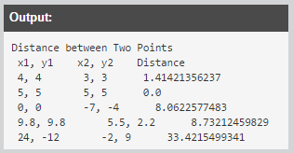

Insert a copy of your code from IDLE here:

Part Three: Post Mortem Review
Complete the Post Mortem Review (PMR). Write a thoughtful two to three sentence response to each of the questions in the PMR chart.

Review Question | Response
What was the purpose of your program?

How could your program be useful in the real world?

What is a problem you ran into, and how did you fix it?

Describe one thing you would do differently the next time you write a program.

